1943 Diary of L J I (Nick) Nickels 1908-1993

Edited, with illustrations added, by Prof Chris Budd OBE (Grandson)

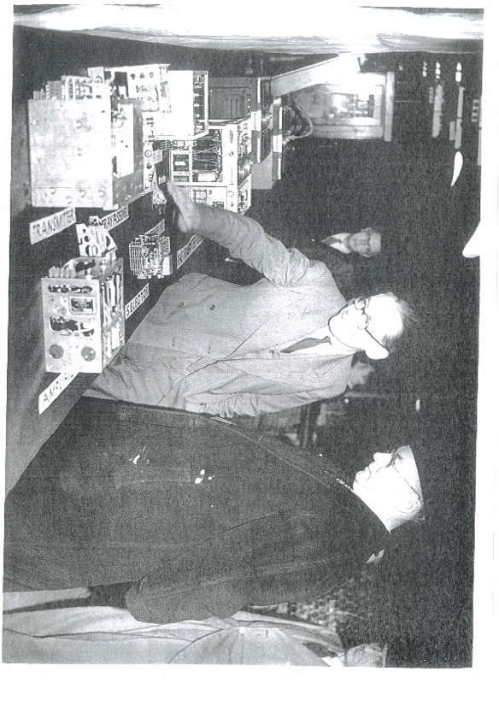
Editors comments [in brackets]. The handwriting in the diary is at some points very hard decipher, and uncertain words are noted in red. A refers to a diary entry, entries without a dot come from his other papers.

L J I (Nick) Nickels in centre demonstrating radio equipment at STC

The diary describes experiments made by my grandfather Nick Nickels during 1943 on the SGP [Standard Glide Path] and the SBA [Standard Beam Approach] blind landing systems for aircraft landing at RAF aerodromes. After a series of set backs, and faulty equipment (which I am sure that you will all recognise), everything finally worked on 1st April 1943! This system was based on the German Lorenz blind landing equipment. The name Standard comes from STC (Standard Telephones and Cables, based at New Southgate works, North London) who were his employers from the early 1930s till his retirement in the 1970s. During this time he worked on the STC R1466 Receiver, and on the TR1143 Radio. He made test flights in the Vultee-Stinson Vigilant, and in the Airspeed Oxford and in the main was based at RAE (the Royal Aircraft Establishment) Farnborough. He also visited RAF Defford, RAF Oakington, RAF Bicester (the 1551 Beam Approach Calibration Flight), RAF Ford, RAF Bradwell Bay, RAF Hendon, De Havilland Hatfield, as well as the Air Ministry. Many people are mentioned in the diary. Most I believe were fellow STC employees. He was also flown around by members of the RAF/RAE including: F/O Elliott, F/O Falk, W/O Kilgour , F/Lt R.G. Noble, and F/O Sewell. Notably he also records meetings with Watson-Watt (the inventor of British Radar) and the American Ambassador Jon C Winant.

Diary and Other Entries

Friday January 8th 1943

RAE

Thursday January 14th 1943

RAE

- Wednesday January 27th 1943

1143 - Walker came

[This is a reference to the TR1143 Radio which is used a lot for the experiments, see: http://www.vmarsmanuals.co.uk/archive/1601_TR1143A_Vol_1.pdf ]

- Tuesday February 23rd 1943

Took 1st plane SGP [Standard Glide Path] receiver to [RAE] Farnborough for them to install in the Vigilant [aircraft]. No immediate action possible as Oxford [aircraft] out of action with failure of wings and Vigilant in use for other work, and RAE engineers all on leave. Action paused next week.

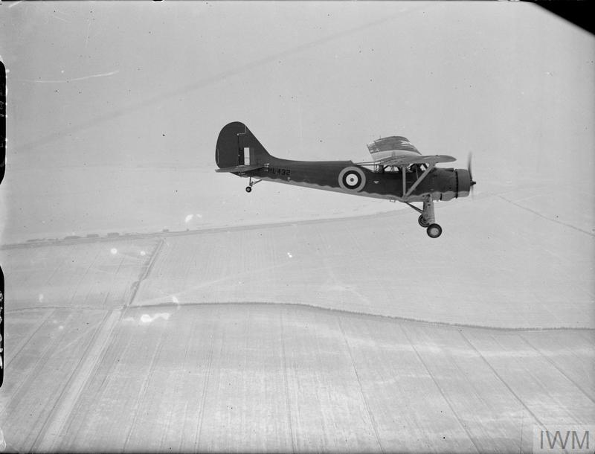

Vultee-Stinson Model 74 Vigilant
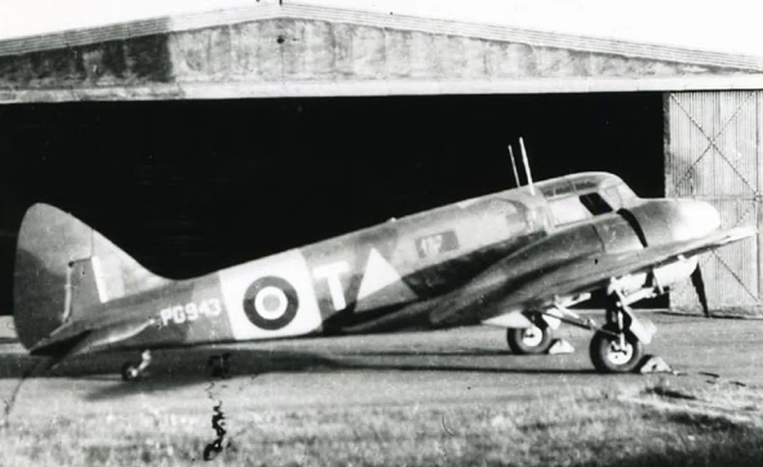

Airspeed Oxford in markings used for beam approach training. A similar aircraft is preserved at the RAF Museum in Hendon.

- Monday March 1st 1943

Sealte went to valve conference on miniature valves at K-B Footscray

[Kolster-Brandes in Footscray, Kent, was famous radio company acquired by STC in 1938]



- Tuesday March 2nd 1943

T.C.C. [? Technical Control Centre] committee at 2.15 [pm]. Discussion on miniature components.

- Wednesday March 3rd 1943

1143 [Radio]

Meeting 10am on 1143 – CGS, Pheazey, Ellis, Hellbing, Palmer, Brusher. Claimed hold up due to valves dying in final test.

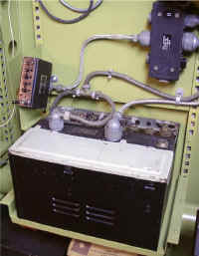
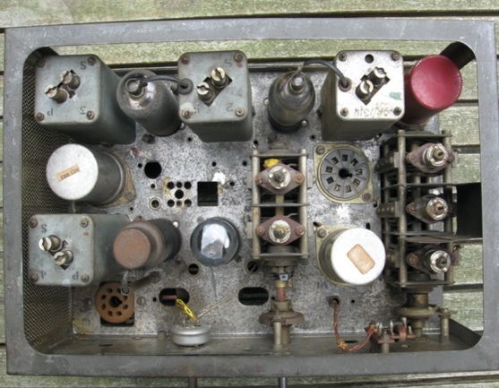

TR1143 Radio with valves

CGS [unknown abbreviation] investigated in afternoon and concluded N.O. [Normal Operation] weak but saw no evidence of valves dying. Davy said that valves dying only experienced in about 1 set in 10.

Thursday March 11th 1943

RAE

- Monday March 15th 1943

S.G.P. [Standard Glide Path]

[RAE] Farnborough to fly the glide path.

1st. with Wells 2nd No beam - found due to faults in receiver. But Beam actually had no keying duct in any case. Then indications very erratic and all signs of broken connection to aerial plug. Left to be repaired, and brought rec.[eiver] back for final once over. To return Wednesday. Seen Falk who said Grey just back. Meeting at MAP [Ministry of Aircraft Production] tomorrow 15 mins. flying (3.07-3.22 [pm]) in Vigilant. Tea in Sunningdale Café (shuts at 6) Bealtie’s Restaurant! (Also bolt broke in A/C!) [aircraft]

- Tuesday March 16th 1943

S.G.P : - Hanning, Westian and Sean worked on SGP receiver and put in new diode box, finally testing at 11.30 pm.

1143 – sent letter to DC Deb requesting accessories on 1143

- Wednesday March 17th 1943

SGP – no flying in morning due to mist. No approaches in afternoon, and runway reversed. 3 level flights indicated receiver working and no crazy effects.

- Thursday March 18th 1943

SGP Beautiful day, but runway reversed. [Wind in wrong direction I assume]

- Monday March 22nd 1943

SGP. Set up new beam.

- Tuesday March 23rd 1943

S.G.P. transmitter valve died

- Wednesday March 24th 1943

1143. Long session all day. First sets going though. NCW [? No carrier wave] and lack of coverage fault. Action applied to clear these and manufacturing meeting advised.

- Thursday March 25th 1943

De Jong joined. Passed to Neuten. Walker left

- Friday March 26th 1943

R.A.E all day. Flew 15 mins in Vigilant with new rec.[eiver] and new beacon, No results.
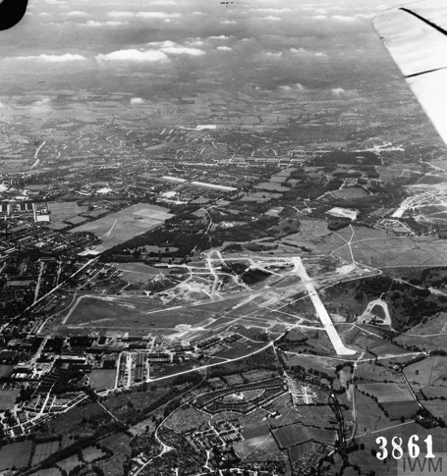

RAE Farnborough airfield during WW2

- Monday March 29th 1943

SGP. DA. Ran up receiver No 1 in Vigilant on ground, with old beacon.

- Tuesday March 30th 1943

SGP. [at RAE]

No 1 [receiver] ok on ground in Vig[ilant]
No 2 ok

Flew with No 2 (co) and made two level flat runs No Min compression

Full up and down and c/o. Occasional sporadic leaps of meter connecting with near extinguishing
Very strong and gusty wind stopped flying

Took receiver No 2 down, and [F/O] Weston who made the above flight.

- Wednesday March 31st 1943

1460 meeting [I assume that this is another radio system]

SGP advised Wallace is test engineer

DA advised that [F/O] Sewell refused to fly due to wind levels. Wells advised and was unable to change his decision.

The Oxford which Wells advised could be ready by midday had in fact had nothing done to it bar changing the aerial plug: the test promised was mid morning on Ap[ri]l 1st

New petrol set seen by makers and generator taken away.

- Thursday April 1st. 1943

1143 Discussed the Amis receiver test result with Amis and Shenes and agreed that we could calibrate advised WP and he requested Baltom to ship it out (about 11am) Chased Baltom pm and found it still not shipped due to shortage of parts.

S.G.P. Results at last – rec.[eiver] No 1 and old beacon. Weather still bad but flights made morning and afternoon in Oxford. Falk flew in morning, Sewell in afternoon. Rattue went to [RAE] Farnborough. New petrol set away.

- Friday April 2nd 1943

TBA. [RAF] Bicester to see Feuce. (also visited RAE)

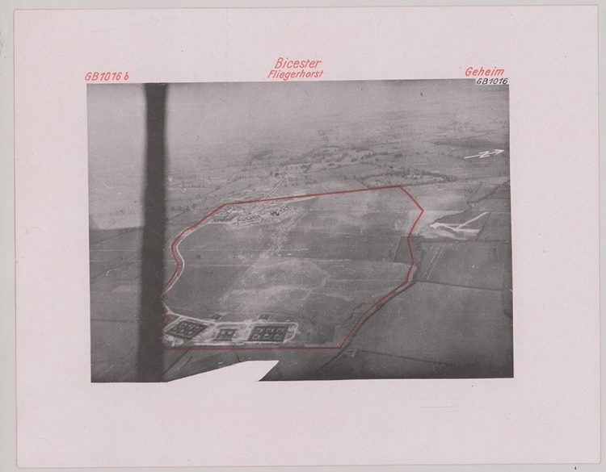

German wartime photograph of RAF Bicester

Took 6 receivers R1466 with control units
Cost of

[British RAF navigation beam airborne receiver R1466. This was made by STC to a German Lorenz design. It was used by the RAF in 1939-1945. For more details see: https://www.iwm.org.uk/collections/item/object/30005751 ]

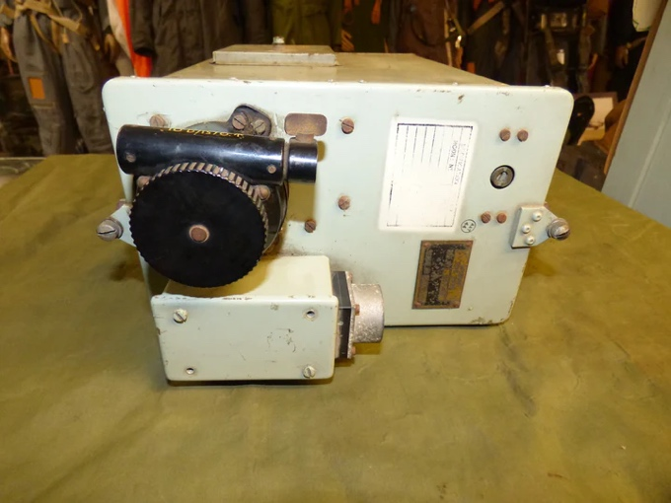

R1466 Beam Airborne Receiver (made by STC)

Get to single coaxial 400 2 Eyelet for Femto

Test set type 11 and 98

Same transmit case

- Saturday, April 3rd 1943

Flew from [RAF] Bicester in Oxford KQ-Q. F/O Sewell 25 mins (also visited RAE)

SGP F/O Sewell Oxford DF [Direction Finding] 30.5 mins

1143 Avis generator, requested Thursday rec. 2pm today

[ From the Bicester airfield record: In July (1942) the Blind Approach Calibration Flight moved in from Watchfield with Ansons, Masters and Oxfords to check and calibrate equipment used at bomber bases. It was redesignated as 1551 Beam Approach Calibration Flight (BACF) during November.
https://www.blhs.org.uk/uploads/documents/RAF%20BICESTER%20CHRONOLOGY(%20illust).pdf ]

- Monday, April 5th 1943

Try and get SGP rec.[eiver] to set A for bench tests this week

SGP
Bentley [Priory] NE St Albans

1143 Unipelly and Pym came to discuss concessions on fuel drive

Mechanics spent receiver clearing backlash in attenuator

- Monday, April 12th 1943

SGP Westian suggests reducing the injection by reduction of H.T. [High Tension] (with decoupling condenser) suggest we try cans on the valves and a copper screen round the back

TBA Set Neut[en] to test doped trimmer and also to measure same trimmer before and after doping

Talk to Wells and ask him to recall itoline sets on grounds of what we have found re doping of trimmers

A/C [aircraft] Heavies S/C Saken hrs

Tuesday April 13th 1943

RAF Bicester

Thursday April 15th 1943

RAE

This visit was recorded in a detailed graph of two flights using the FDR [flight data recorder] measuring the beam.

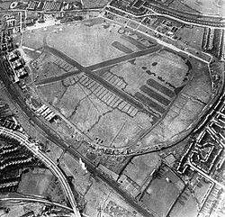
Friday April 16th 1943

RAF Hendon.

- Tuesday May 4th 1943

SGP Xtr [transmitter] broke down

- Wednesday May 5th 1943

SGP DV 34 Xtr [transmitter] taken down in evening of $√τ$ of R

- Friday May 7th 1943

1143 Meeting on service changes. Hadley, Lawrence, Baker

Tuesday May 11th 1943

RAE

- Wednesday May 12th 1943

1143 Shipments stopped as from tonight for implementation of service mod changes

- Monday May 17th 1943

SBA Oscar and Gilderdale took 6 – 1466 receivers new style to [RAF] Bicester

- Thursday May 20th 1943

SGP RAE Addressed Bricknall re alleged “dwell” on upper side believed due to rapid passage from high level to nose of 2nd lobe. [Radio signals had lobes where they were strongest. The nose was the point of the lobe] Flights in afternoon with external camera. Took down monitoring receiver and bits, with Baron Edwards. Saw rec. and XG.

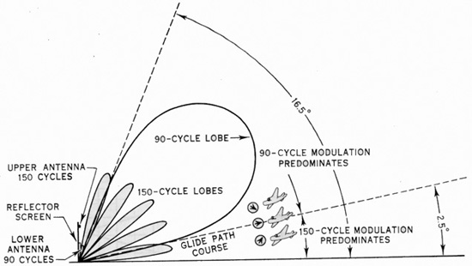

Typical SBA signal pattern showing the lobes, with the nose at the end
https://muse.jhu.edu/pub/1/oa_monograph/chapter/67785

SBA [ Standard Beam Approach https://en.wikipedia.org/wiki/List_of_Beam_approach_beacon_system_units ].

Took down model of R1466. Inspected by Edwards and Woods. Told of meeting on SBA Finding nil with Neunich and Watson Watt [inventor or Radar] on tunable receiver
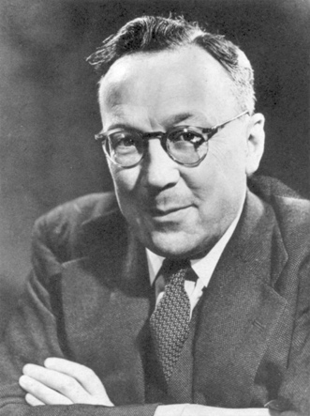

Sir Robert Watson Watt, inventor of British Radar

Edwards and Brichall to be present

- Friday May 21st 1943

Rang Edwards re measurement figures on 1466

SBA – Big meeting at A.M. [Air Ministry] on B.A. [Beam Approach] Delieve Watson Watt Neunich + ??? Harris

- Friday May 28th 1943

RAE with Willoughby

- Saturday May 29th 1943

RAE with Willoughby. Brought accumulator back

- Sunday May 30th 1943

Sam Ellis 54 Marlbrgh Gdns.

Accumulator has beaming slop

Thursday June 3rd 1943

RAE

- Tuesday June 15th 1943

Passed SGP description to CGS

- Wednesday June 16th 1943

Meet ReF at Shoebury Hotel 12.30. [Shoeburyness Hotel, Southend-on-Sea]

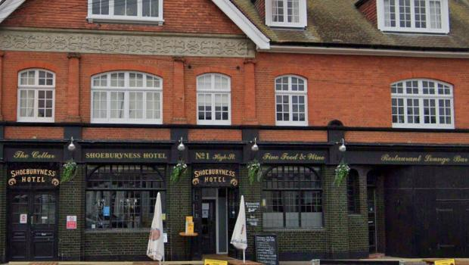

- Tuesday June 22nd 1943

Dpin + Bennet of Emi to obtain 1143 I.F. resistors [Intermediate Frequency]

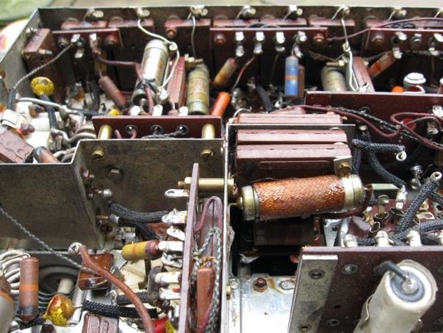

TR 1143 Resistors

Saturday June 26th , 1943

RAE.

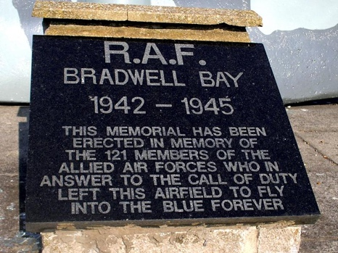
Friday July 2nd , 1943

RAF Bradwell Bay, Essex.

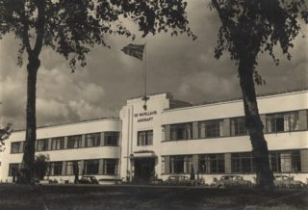
Monday July 7th, 1943

De Havilland, Hatfield.

August 13th , 1943

RAE.

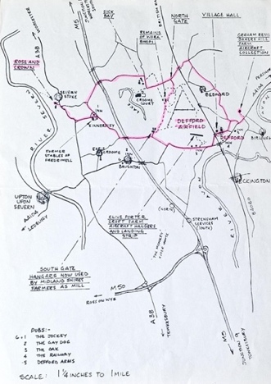
August 25th ,1943

RAF Defford

26th August 1943

RAF Defford. This visit was recorded in a graph of measurements made

27th August 1943

RAF Defford

Saturday 4th September 1943

RAE

- Monday, September 6th, 1943

[The diary here records in detail a bus journey from his home in North Wembley to the STC New Southgate works in Barnet]

16 Bus. E[ast] Lane. 8.07. [am] [East Lane, North Wembley]
arr N. 8.17½ [am] [Possibly Neasden]

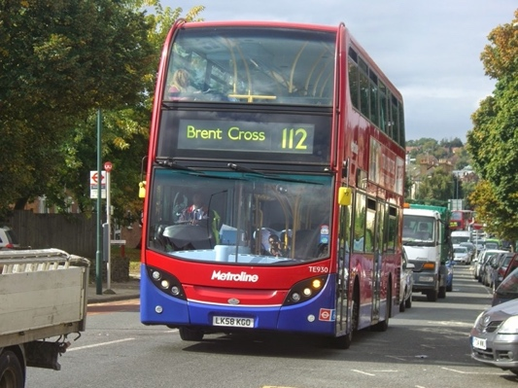
112 N. 8.18 [am]

Brent cross
112 crossloils

N. Lady 8.30. [am]

[The 112 Bus route has a long history and is still running
https://bus-routes-in-london.fandom.com/wiki/London_Buses_route_112 ]

1 Bowes Rd 8.43 ½ [am] [Palmers Green, North London]

34. left 8.44 ½ [am]

AG. 8.46. [am]
[Arnos Grove]

10

- Tuesday, September 7th , 1943

16 – E Lane. 8.08 [am] (watch 4 1/T)

112. P.G. [Palmers Green]. 8.19 [am]
8.47 [am]

Missed thru bus at 8.48 h [am]

Next shown is. 8.59 [am]

Arr at gate 9.05 [am]

- Wednesday September 8th 1943

8.07 ½

18 ½

112. 19 PG. [Palmers Green]

Measurements recorded on a graph at RAF Defford

Thursday/Friday 9-10th September 1943

RAF Defford . More measurements with graph

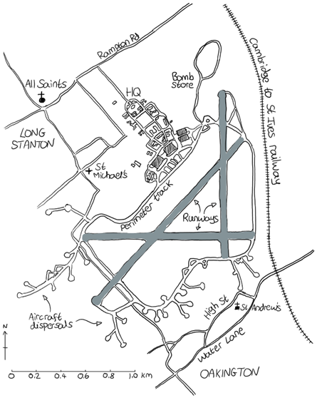
- Friday September 17th 1943

To RAF Oakington

F/Lt R.G. Noble. w/o Kilgour

Wartime layout of RAF Oakington

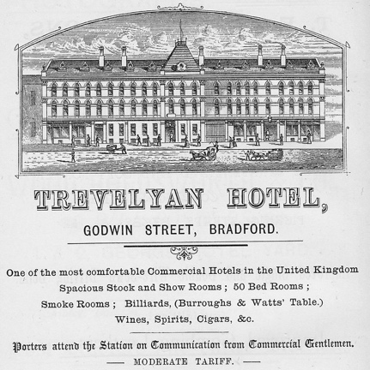
- Monday September 20th 1943

Room 22
Trevelyan Hotel.
(Godwin Street).
Bradford

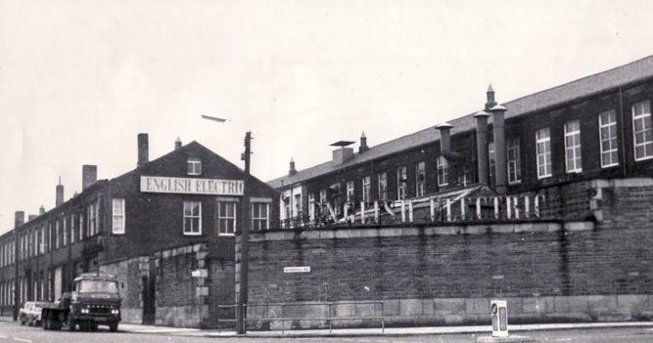
Thursday September 23rd 1943

GEC (English Electric) Bradford

- Tuesday October 5th 1943

DHQ for eye shield 19-11 on 7th

Friday October 15th 1943

RAE

- Tuesday October 19th 1943

[STC] Works visited by Col. Belin with Ambassador John G Winant [US Ambassador], Lord Gowan and many others. Taken by Spencer, Sheif, Pheazey, Helbing, Pace, Gil, Break. Saw them on 1143 [radio] demonstration point

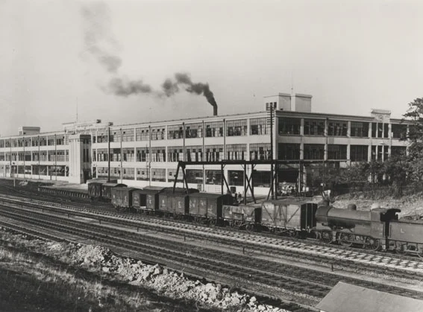

STC New Southgate works

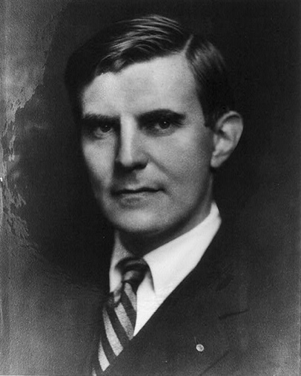

John G Winant, US ambassador to the UK

Tuesday/Wednesday 16-17th November 16th-17th 1943

GEC Bradford

Monday November 22nd 1943
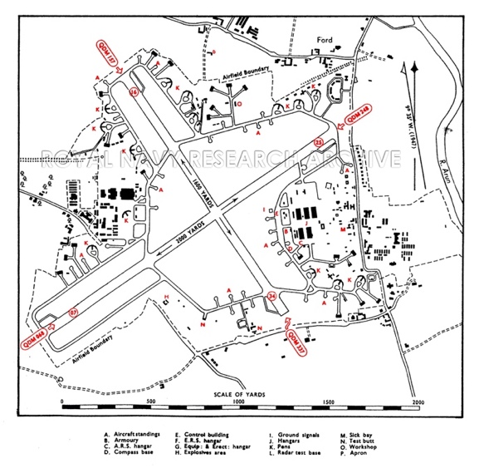
RAF Ford (Yapton)

Tuesday December 21st 1943

RAE

